**Topic: finance case study**

**Group members: ZHU Huilei & SYBOU Kaoutar**

**WW analysis**

1. Elaborate a tab ranking country by revenue

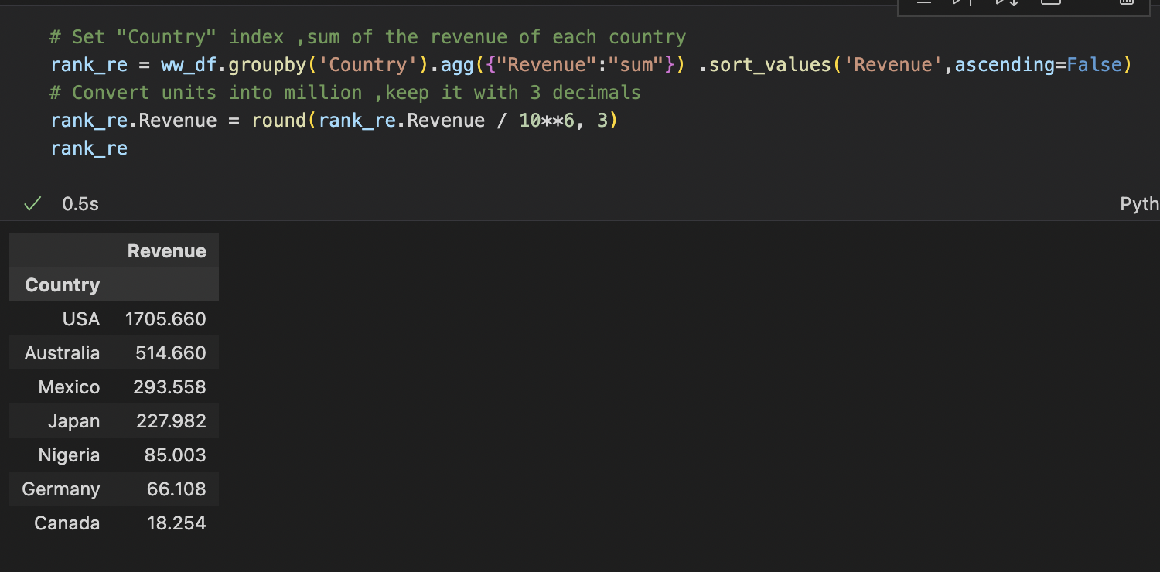

1. Which countries have the most important revenue growth (in %) between 2011 &2012?

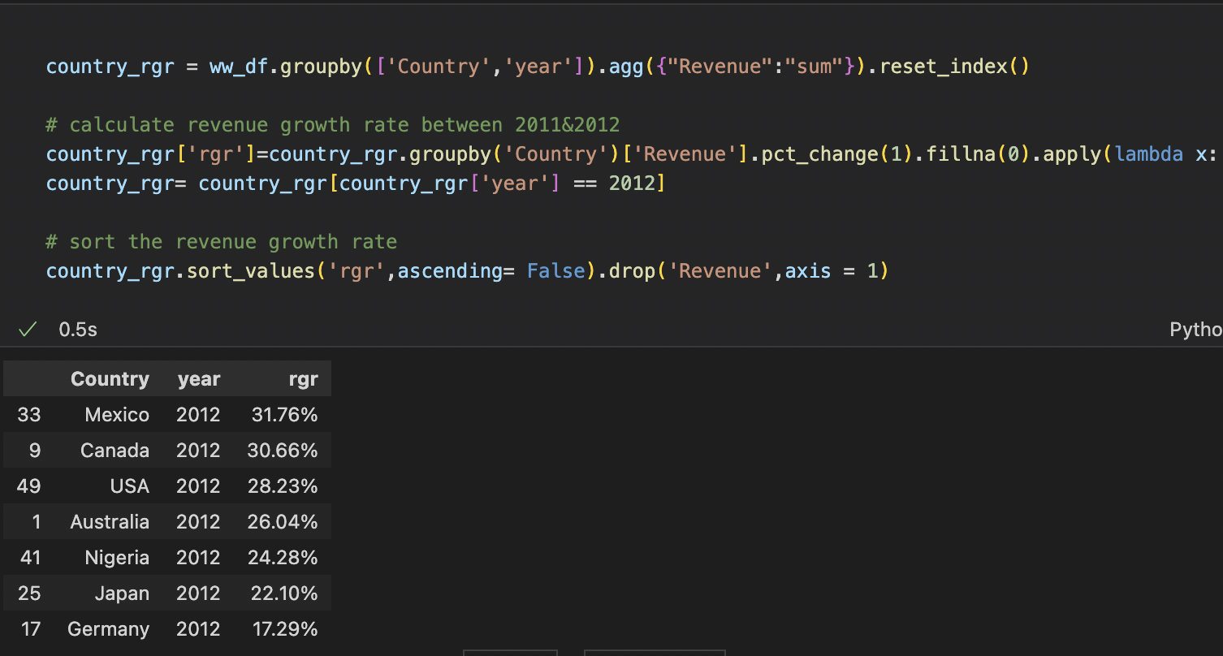

1. Which countries have the most important cumulative revenue growth (in %) between 2011 to 2018?

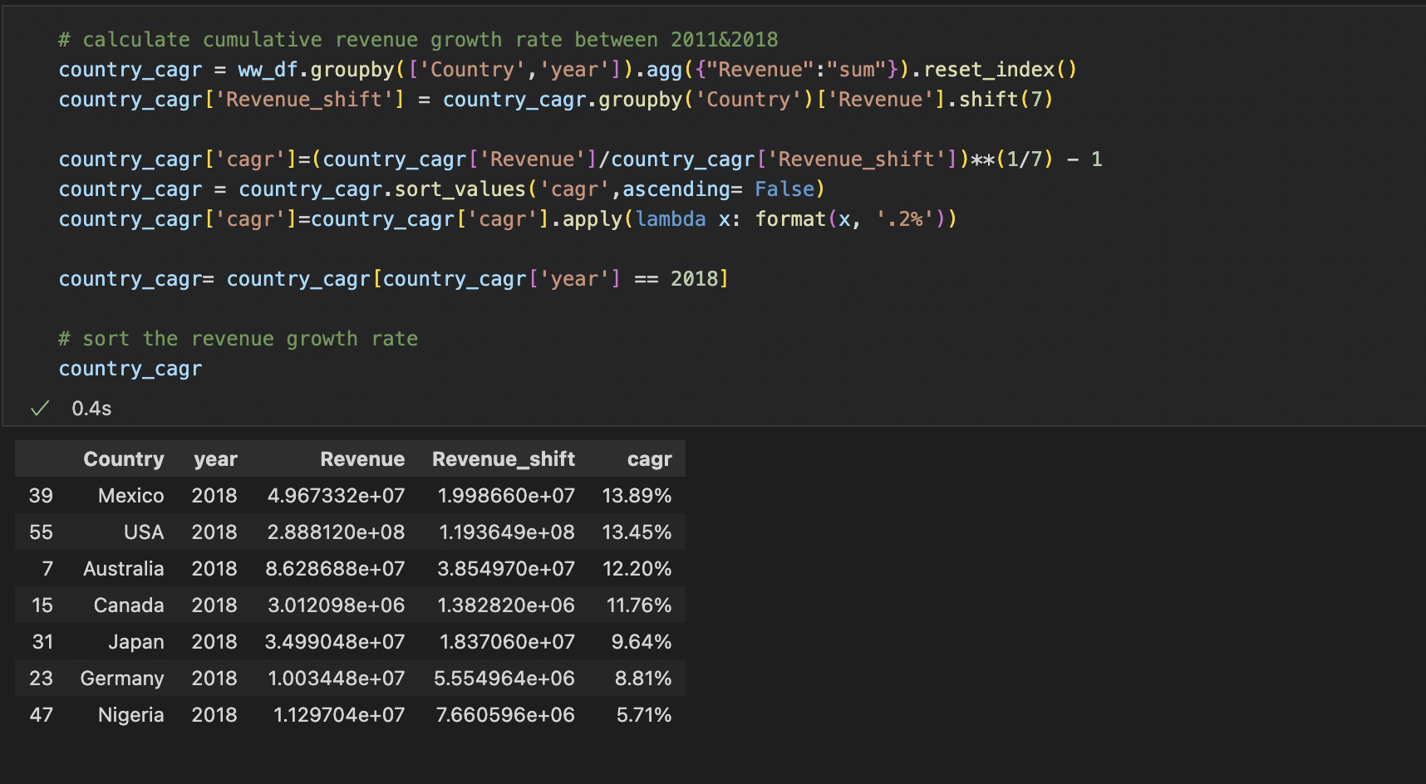

1. List the top 5 best-selling products in the world

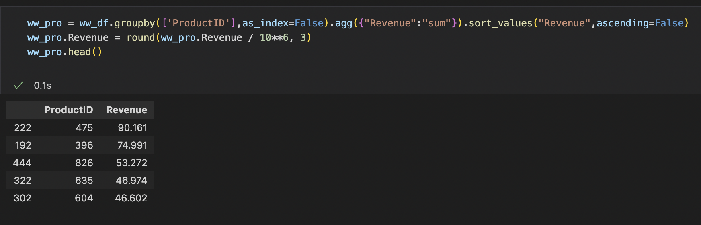

5) List the top 5 best-selling products in Japan 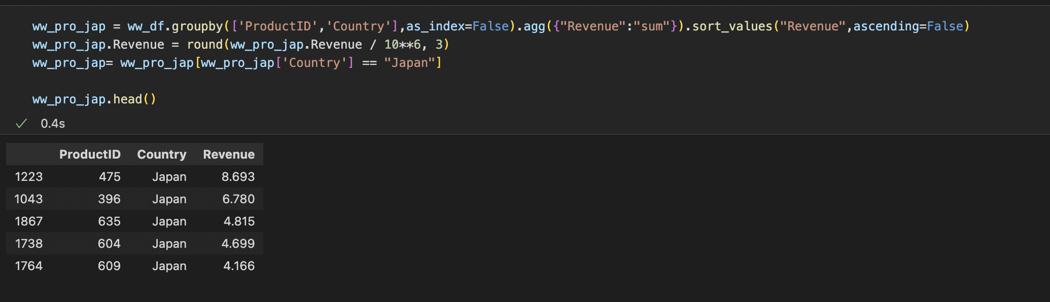

6) What is the most expensive product? 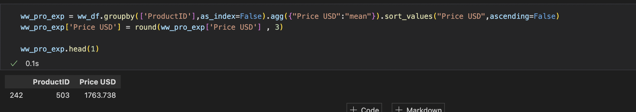

7) What is the biggest [manufacturer] contributor to revenue in the world? 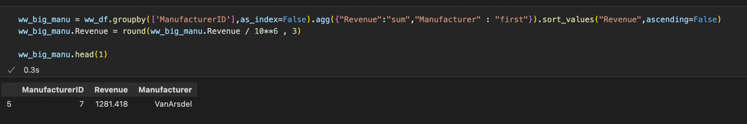

8) List the bottom 3 [manufacturer] contributor to revenue in Nigeria 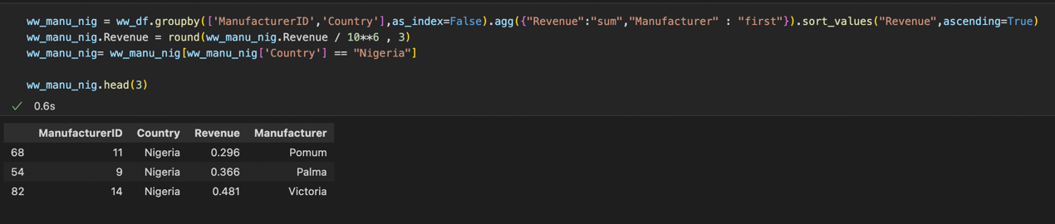

9) Provide the list of products with no revenue in 2017 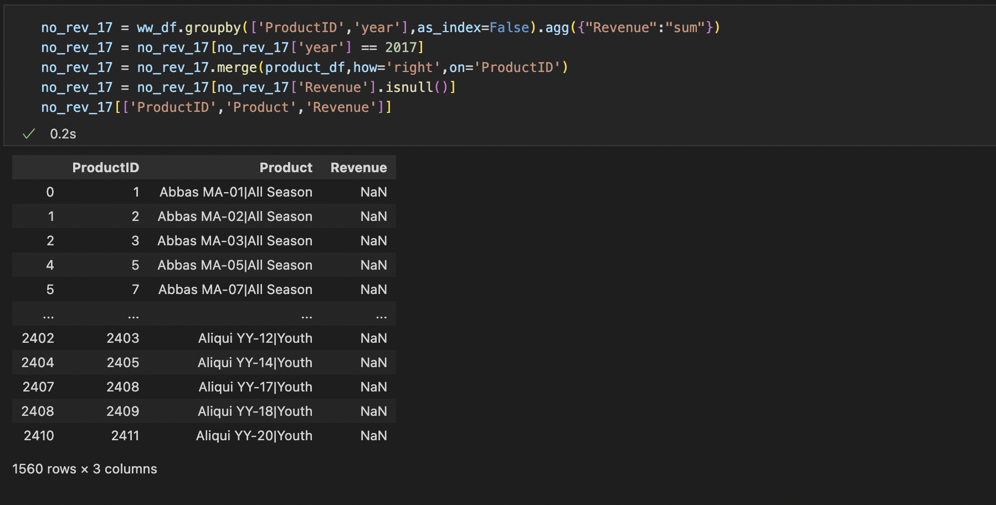

10) Provide the list of products with no revenue in 2017 & 2018 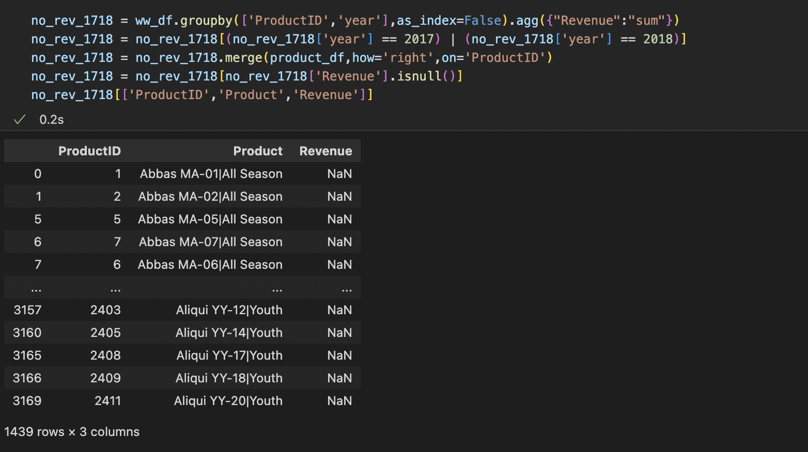

11) Provide a list of the top 3 products with the most important growth (in value) between 2016 to 2017 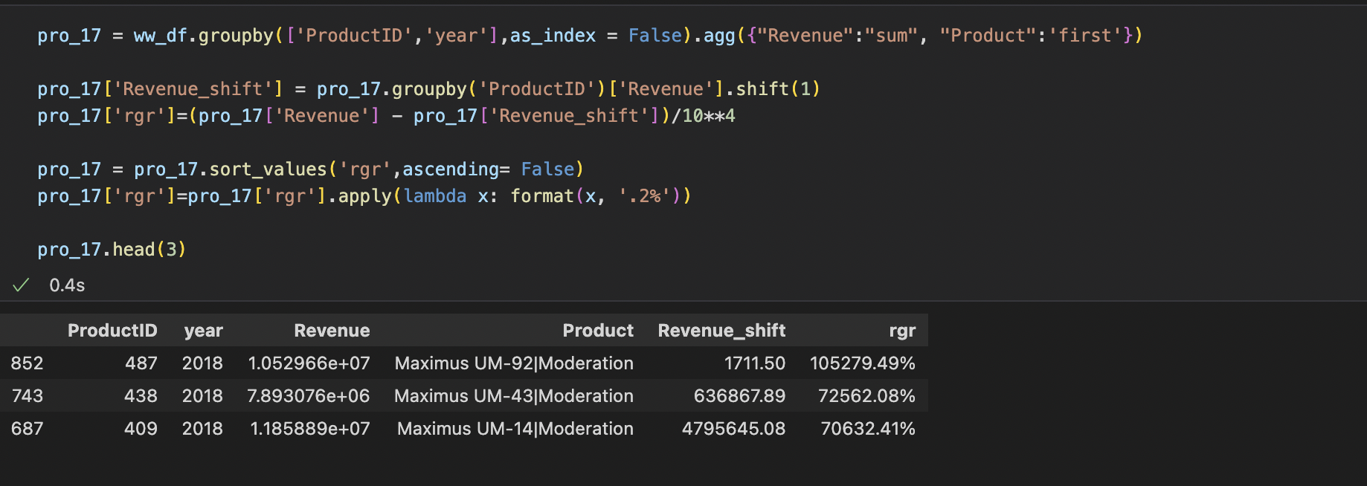

12) Is Blue Corporate a seasonal business? (Y/N) If yes: decompose this time series between seasonality & trend?

Yes,Blue Corporate is a seasonal business

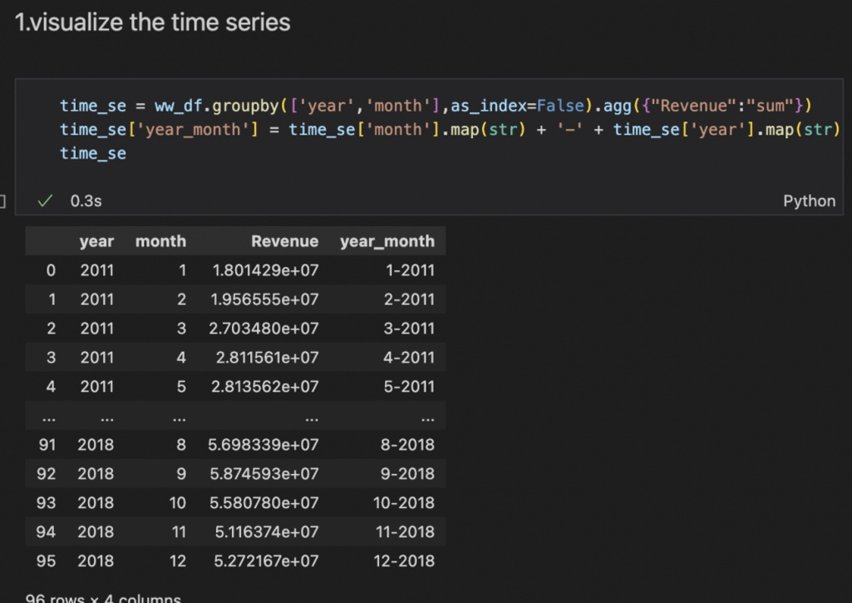

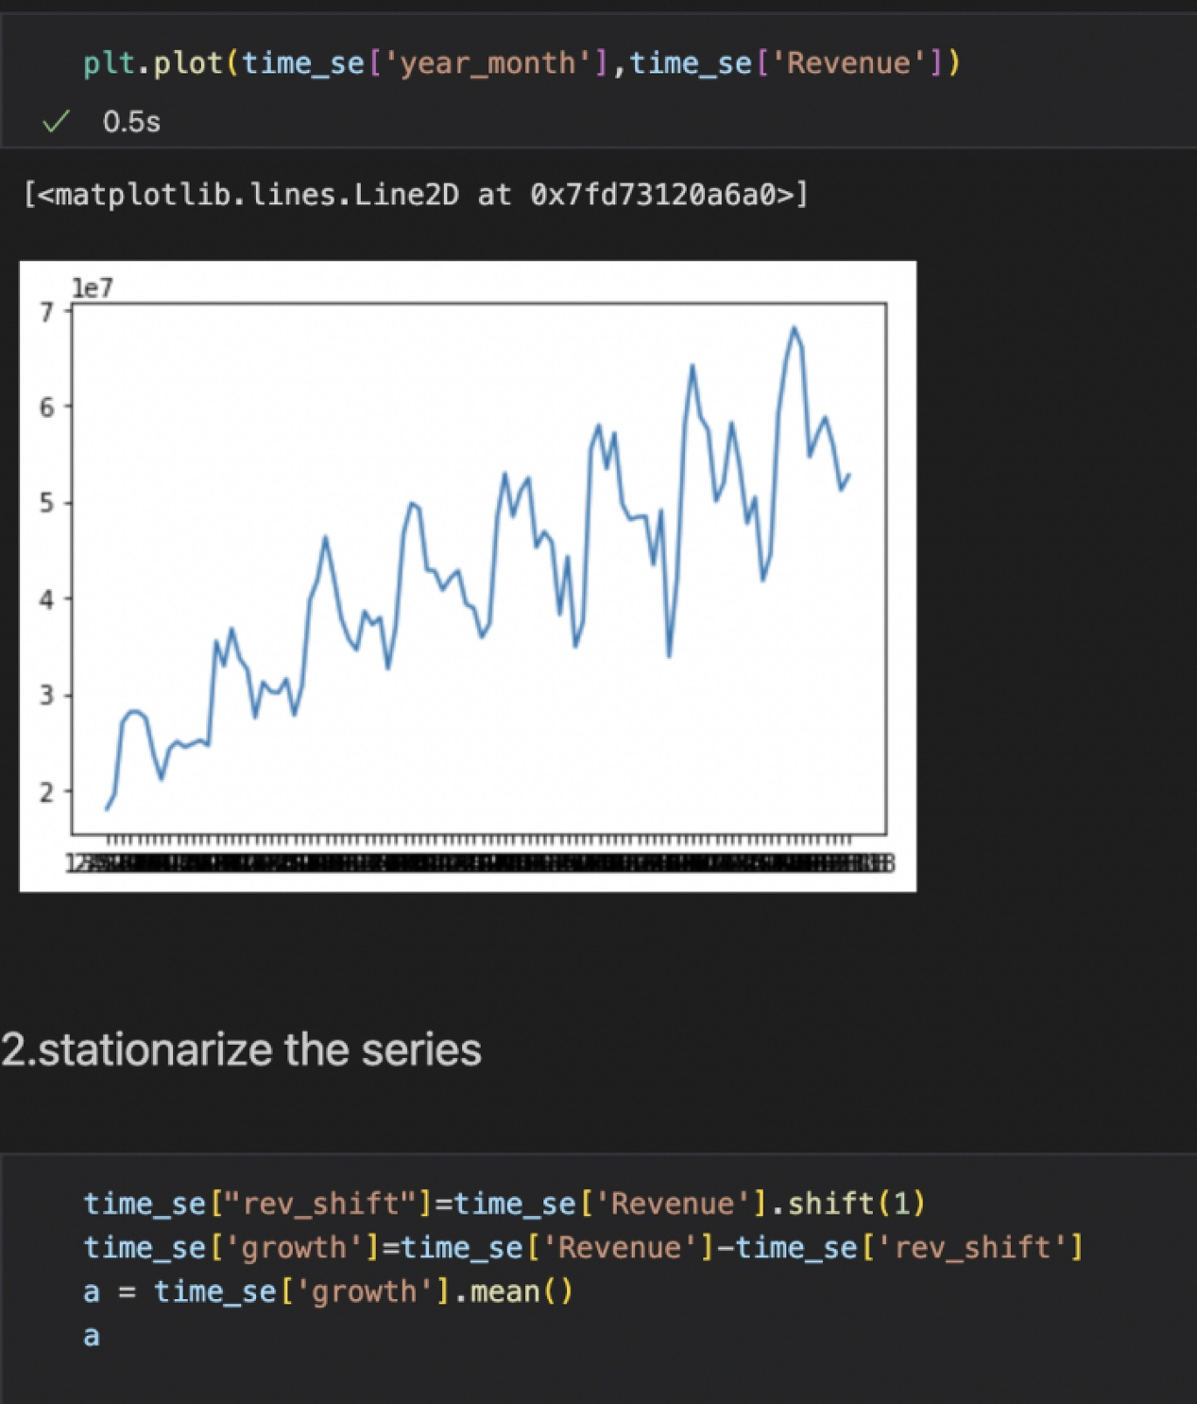

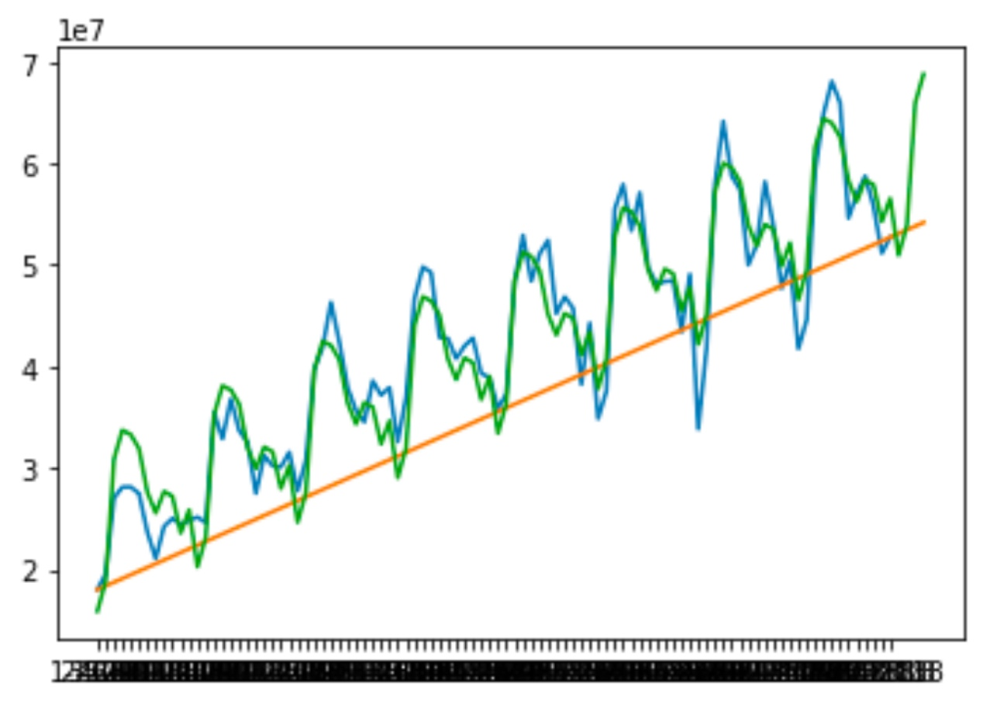

**NAM analysis**

1. Provide revenue of USA & Canada in January 2015

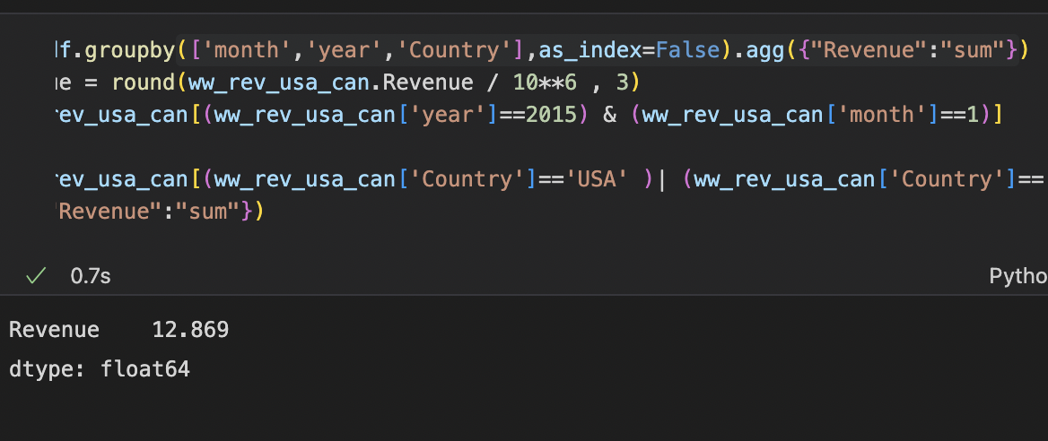

1. In USA what is the top 3 states contributor to revenue?

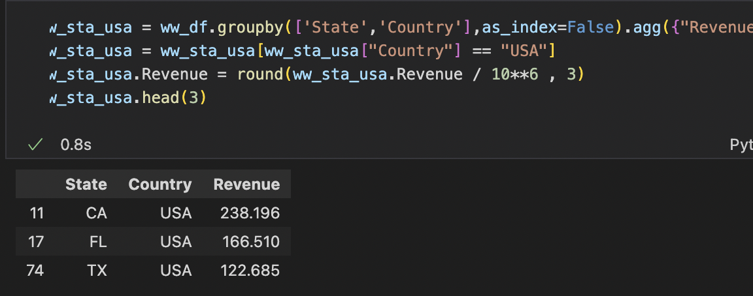

1. In USA what is the region with the most important share of revenue?

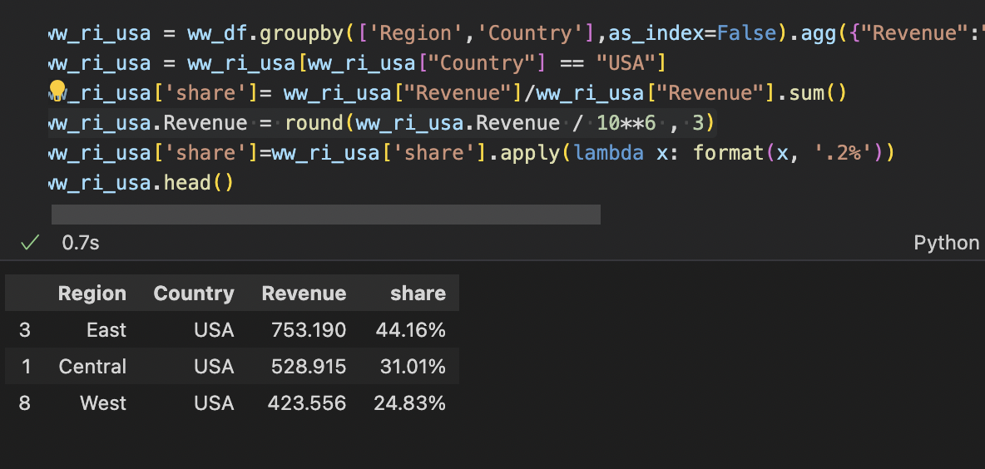

1. In USA for 2014, what is the top 3 states with the most important volume of unit?

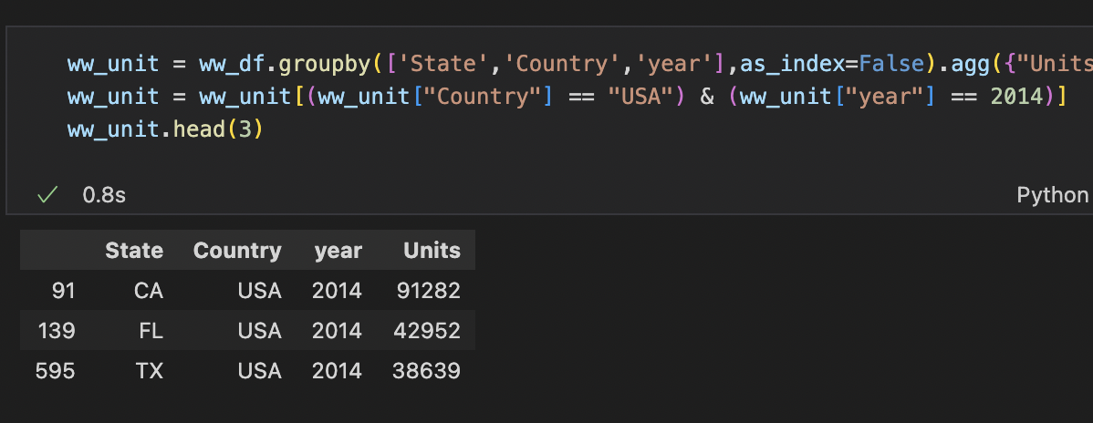

1. In Canada for 2017, what is the state with the most important volume of unit and revenue?

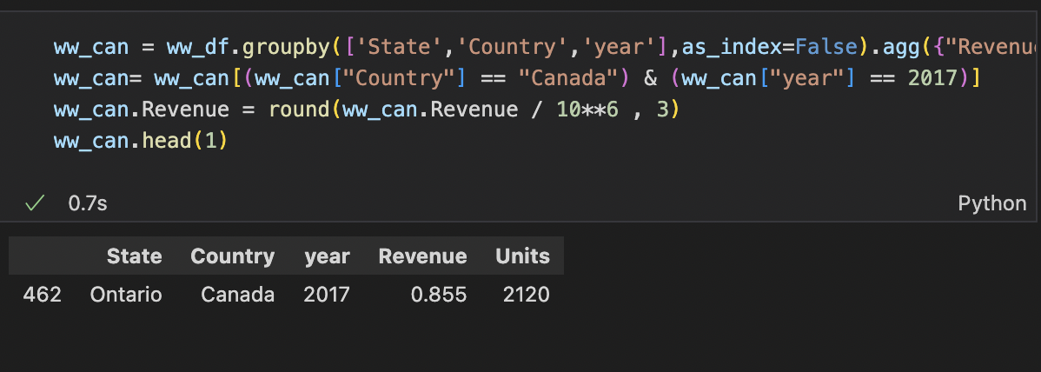

**Executive Presentation 2 Slides**

18) Dashboard View – Mockup about 2018 choose one country – Key Message

19) WW forecast for 2019 using ARIMA Model (Simple Model)

